Single Tier
- Time of Huge Mainframe
- All processing in a single computer
- All resources attached to the same computer
- Access via dumb terminals
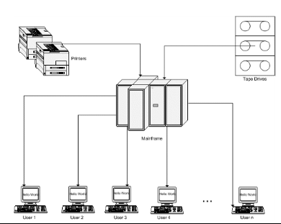

The specific meaning of the term dumb terminal can vary depending on the context in which it is used.
In the context of traditional computer terminals that communicate over a serial RS-232 connection, dumb terminals are those that can interpret a limited number of control codes (CR Carriage return , LF Line Feed, etc.) but do not have the ability to process special escape sequences that perform functions such as clearing a line, clearing the screen, or controlling cursor position. In this context dumb terminals are sometimes dubbed glass Teletypes, for they essentially have the same limited functionality as does a mechanical Teletype

2 Tier Architecture
The two-tier architecture is like client server application. The direct communication takes place between client and server. There is no intermediate between client and server.
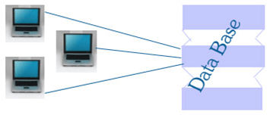

The above figure shows the architecture of two-tier. Here the communication is one to one. Let us see the concept of two tier with real time application. For example now we have a need to save the employee details in database. The two tiers of two-tier architecture is
- Database (Data tier)
- Client Application (Client tier)
So, in client application the client writes the program for saving the record in SQL Server and thereby saving the data in the database.
Advantages:
Understanding and maintenances is easier.
Disadvantages:
Performance will be reduced when there are more users.
Business Logic Implemented at client side

3-Tier Architecture
- A three way Interaction in a client/Server environment
  - The user interface is stored in the client
  - The bulk of the business application logic is stored in one or more servers
  - The data is stored in database server
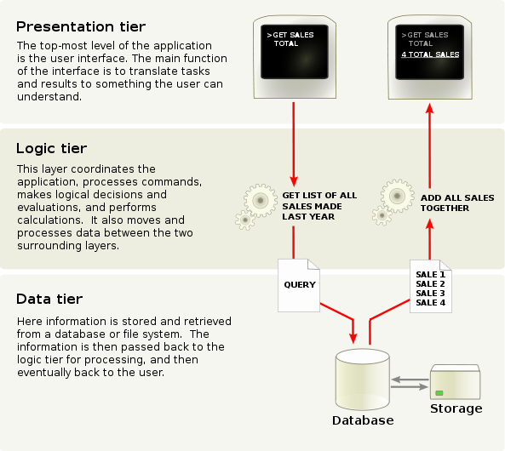

Presentation tier
This is the topmost level of the application. The presentation tier displays information related to such services as browsing merchandise, purchasing, and shopping cart contents. It communicates with other tiers by outputting results to the browser/client tier and all other tiers in the network.
- Logic tier (business logic, logic tier, data access tier, or middle tier)
The logic tier is pulled out from the presentation tier and, as its own layer, it controls an application’s functionality by performing detailed processing.

Data tier
This tier consists of database servers. Here information is stored and retrieved. This tier keeps data neutral and independent from application servers or business logic. Giving data its own tier also improves scalability and performance.

Three tier architecture having three layers. They are
- Client layer
- Business layer
- Data layer
Client layer: Here we design the form using textbox, label etc.

Business layer: It is the intermediate layer which has the functions for client layer and it is used to make communication faster between client and data layer. It provides the business processes logic and the data access.

Data layer: it has the database.

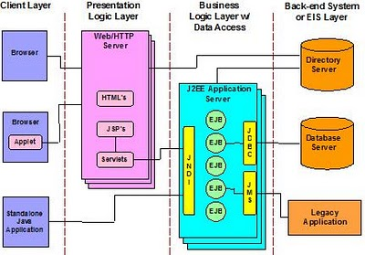
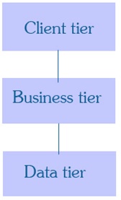

Advantages
- Easy to modify without affecting other modules
- Fast communication
- Performance will be good in three tier architecture.

N-Tier
- Client Layer
- Presentation Logic Layer
- Business Logic Layer
- Backend System or EIS (Enterprise Information Service) Layer

N-Tier Architecture Presentation Logic Layer
The Presentation Layer in an N-Tier structure is commonly referred to as the “client” layer. It consists of parts that are used to present data to an end user. Examples of components on the Presentation Layer might include edit boxes, labels, text boxes, grids, buttons, Windows or Web forms, or more. The Presentation Layer can be either Windows based or Internet based.
The presentation layer is also sometimes referred to as the client layer. It consists of components that serve to present data to the end user. This data might include Windows or online buttons and forms, boxes for editing or texts, grids, labels, and more. In short, the presentation layer is a key component of any N-Tier system; without it, as the name infers, nothing will be presented to the end user, no matter how well the system functions otherwise.

