IRC (Internet Relay Chat)
What is IRC?
IRC - Internet Relay Chat is a method to broadcast and receive live, synchronous, messages. There are hundreds of IRC channels (discussion areas) around the world, hosted on servers, on which people type their messages to others on the same channel interested in the same subject. There are client IRC programs which provide graphical interfaces which make it easier for people log on and access active channels and send and receive the messages. IRC chat, at present, is not limited to two people, unlike earlier versions.
You need a software program to access the IRC channels. The server acts as a router, making sure that all messages are sent to the discussion participants.
There are many different programs that allow you to engage in Internet Relay Chat.
For Windows, for example, there is:
mIRC (http://www.irchelp.org/irchelp/mirc/)
You can download it and try it out for free for 30 days at: http://www.irchelp.org/irchelp/mirc/#download.
For MACs, for example, there is:
Ircle (http://www.ircle.com/)
You can download it and try it out for free at http://www.ircle.com/download.shtml, for a limited time and then register it for a small fee.
When using IRC you assume an identity, so you will be asked to choose a nickname. Since a lot of people use IRC, try to think of a unique name.
You can communicate with other IRC users in two ways, through public channels or private messages only seen by the two people.with other IRC users, through private messages and on channels.
Some IRC channels are invitation only and you will be required to send a message and ask to be invited.
Some basic IRC commands:
/msg nickname message | Sends a private message to the user known by nickname.  Ex: /msg Madcap Have a great holiday!
/me action | Sends a message to the channel describing an 'action' you take. Ex: If your nickname is Madcap and you wanted to "wave" participants in the discussion, you would type the command /me waves. Your "wave" would appear on the screen like this: Ex: /Madcap waves
/join channel | Joins the channel. All channel names begin with the "#" symbol. You must include that in the name. Ex: /join #graphicgeeks
/part channel | Leaves the channel . Because you can be on many channels at once in IRC, you must always include the name of the channel you wish to leave. Ex: /part #graphicgeeks
/nick new-nickname | Changes your nickname to a new one Ex: /nick new-technogeek
/quit | Quits IRC Ex: /quit
* * | * * * * * *
For more IRC commands, go to http://www.irchelp.org/irchelp/new2irc.html#talking

How to install IRC Server
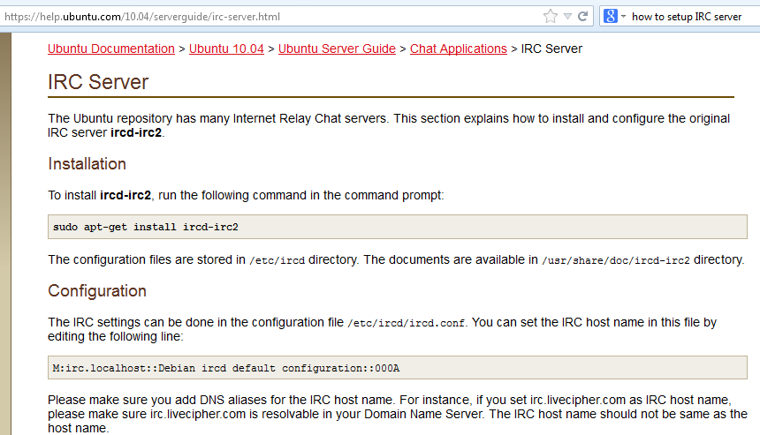

Another IRC server setup in linux-steps
http://0x7e.org/blog/2011/04/05/setup-your-own-irc-server/

