Circuit Switching: Frame Relay, ATM & X.25

Circuit switching
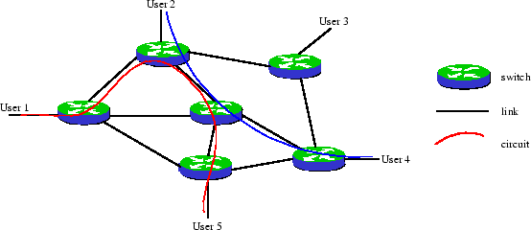
Figure 1.1: Circuit switching. The two different bitstreams flow on two separate circuits.
In circuit switching, a caller must first establish a connection to a callee before any communication is possible. During the connection establishment, resources are allocated between the caller and the callee. Generally, resources are frequency intervals in a Frequency Division Multiplexing (FDM) scheme or more recently time slots in a Time Division Multiplexing (TDM) scheme. The set of resources allocated for a connection is called a circuit, as depicted in Figure 1.1. A path is a sequence of links located between nodes called switches. The path taken by data between its source and destination is determined by the circuit on which it is flowing, and does not change during the lifetime of the connection. The circuit is terminated when the connection is closed.
In circuit switching, resources remain allocated during the full length of a communication, after a circuit is established and until the circuit is terminated and the allocated resources are freed. Resources remain allocated even if no data is flowing on a circuit, hereby wasting link capacity when a circuit does not carry as much traffic as the allocation permits.
A second characteristic of circuit switching is the time cost involved when establishing a connection. In a communication network, circuit-switched or not, nodes need to lookup in a forwarding table to determine on which link to send incoming data, and to actually send data from the input link to the output link. Performing a lookup in a forwarding table and sending the data on an incoming link is called forwarding. Building the forwarding tables is called routing. In circuit switching, routing must be performed for each communication, at circuit establishment time. During circuit establishment, the set of switches and links on the path between the sender and the receiver is determined and messages are exchanged on all the links between the two end hosts of the communication in order to make the resource allocation and build the routing tables. In circuit switching, forwarding tables are hardwired or implemented using fast hardware, making data forwarding at each switch almost instantaneous. Therefore, circuit switching is well suited for long-lasting connections where the initial circuit establishment time cost is balanced by the low forwarding time cost.

Datagram packet switching
Packet switching introduces the idea of cutting data on a flow into packets which are transmitted over a network without any resource being allocated. If no data is available at the sender at some point during a communication, then no packet is transmitted over the network and no resources are wasted. Packet switching is the generic name for a set of two different techniques: datagram packet switching and virtual circuit packet switching. Here, we give an overview of datagram packet switching.
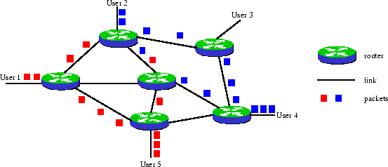
Figure 1.2: Datagram Packet Switching. Packets from a given flow are independent and a router can forward two packets from the same flow on two different links.
Different from circuit switching, datagram packet switching does not require to establish circuits prior to transmission of data and terminate circuits after the transmission of data. The switches, called routers, have to make a lookup in the forwarding table, called routing table, for each incoming packet. A routing table contains a mapping between the possible final destinations of packets and the outgoing link on their path to the destination. Routing tables can be very large because they are indexed by possible destinations, making lookups and routing decisions computationally expensive, and the full forwarding process relatively slow compared to circuit switching. In datagram packet switching networks, each packet must carry the address of the destination host and use the destination address to make a forwarding decision. Consequently, routers do not need to modify the destination addresses of packets when forwarding packets.
Since each packet is processed individually by a router, all packets sent by a host to another host are not guaranteed to use the same physical links. If the routing algorithm decides to change the routing tables of the network between the instants two packets are sent, then these packets will take different paths and can even arrive out of order. In Figure 1.2 for instance, packets use two different paths to go from User 1 to User 5. Second, on a network topology change such as a link failure, the routing protocol will automatically recompute routing tables so as to take the new topology into account and avoid the failed link. As opposed to circuit switching, no additional traffic engineering algorithm is required to reroute traffic.
Since routers make routing decisions locally for each packet, independently of the flow to which a packet belongs. Therefore, traffic engineering techniques, which heavily rely on controlling the route of traffic, are more difficult to implement with datagram packet switching than with circuit switching.

Virtual circuit packet switching
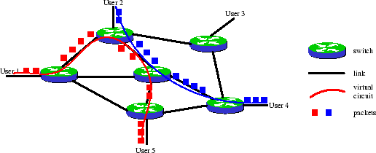
Figure 1.3: Virtual circuit packet switching. All packets from the same flow use the same virtual circuit.
Virtual circuit packet switching (VC-switching) is a packet switching technique which merges datagram packet switching and circuit switching to extract both of their advantages. VC-switching is a variation of datagram packet switching where packets flow on so-called logical circuits for which no physical resources like frequencies or time slots are allocated (see Figure 1.3). Each packet carries a circuit identifier which is local to a link and updated by each switch on the path of the packet from its source to its destination. A virtual circuit is defined by the sequence of the mappings between a link taken by packets and the circuit identifier packets carry on this link. This sequence is set up at connection establishment time and identifiers are reclaimed during the circuit termination.

